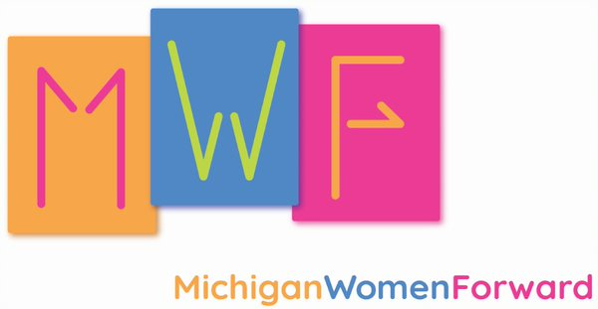

3/20/2021

To whom it may concern,
Anna Blanchet was the Marketing and Communications Intern with Michigan Women Forward from November 2020 to March 2021. As her direct supervisor, I had the pleasure of watching Anna grow tremendously as a marketing professional and I am confident that she will continue to excel in any position in the marketing and communications field.
Anna is an independent and motivated worker with an ability to learn quickly and take on multiple projects at once. In her position with MWF, she swiftly picked up skills like writing content for social media, writing key pieces of the organization’s communications strategy, designing graphics in Canva, leading projects across interdepartmental teams, and updating and restructuring the Michigan Women Forward website on Wordpress. I would often ask Anna to complete a project and she would report that she had already done it in anticipation of me asking, demonstrating her motivation, ability to think ahead, and use her time effectively.
Due to the COVID-19 pandemic, Anna worked remotely for almost 100% of her internship. Although working remotely can be challenging for new team members, Anna stayed focused and was able to complete complex tasks in short periods of time with minimal direction. Anna tracked her work in a detailed way so that she could pick up where she left off the following week. Anna was also consistently open to getting feedback on her work and making revisions when necessary.
Anna has a positive attitude and professional demeanor which fit in perfectly with our culture at Michigan Women Forward. I am confident that Anna will be an excellent addition to your team.
Please feel free to contact me at 248-933-2901 if you have any questions.
All my best,
Hannah Heebner
Development Manager
Michigan Women Forward
hheebner@miwf.org

